# Project Title: Hotel Rating System

**Description:** The Hotel Rating System is designed to allow users to rate hotels from any location, providing a seamless and user-friendly platform for evaluating accommodations. Users can submit ratings and reviews, which are then aggregated and displayed to help others make informed decisions when choosing hotels. The system ensures a smooth user experience by implementing fault-tolerant microservices and reliable inter-service communication.

**Technologies Used:**

* **Backend:** Java, Spring Boot
* **Database:** MySQL
* **Cloud:** Spring Cloud
* **API Management:** API Gateway
* **Fault Tolerance:** Resilience4j for Circuit Breaking
* **Inter-Service Communication:** Feign Client

**Responsibilities:**

* **Microservices Development:** Built RESTful microservices to handle hotel ratings, user management, and reviews. These services were integrated with a MySQL database for data persistence.
* **Fault Tolerance:** Integrated Resilience4j to implement circuit breakers and ensure that services remain operational even when external services fail, enhancing system reliability and availability.
* **Service Communication:** Utilized Feign Client to enable efficient inter-service communication within the microservices architecture, streamlining the flow of data and interactions between services.
* **API Gateway:** Configured the API Gateway to manage and route incoming traffic to the appropriate microservices, ensuring scalability and security of the system.

窗体顶端

窗体底端

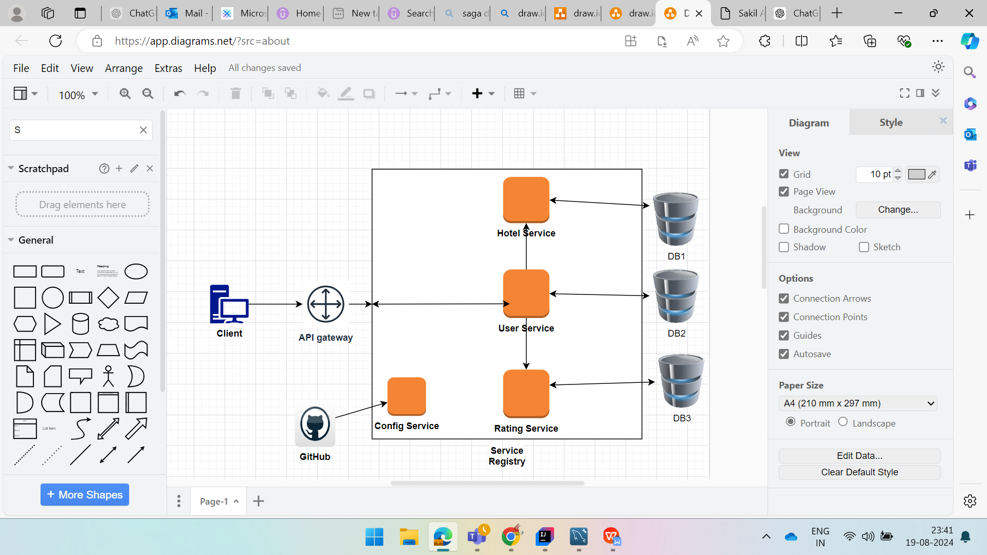

**Hotel Rating System**

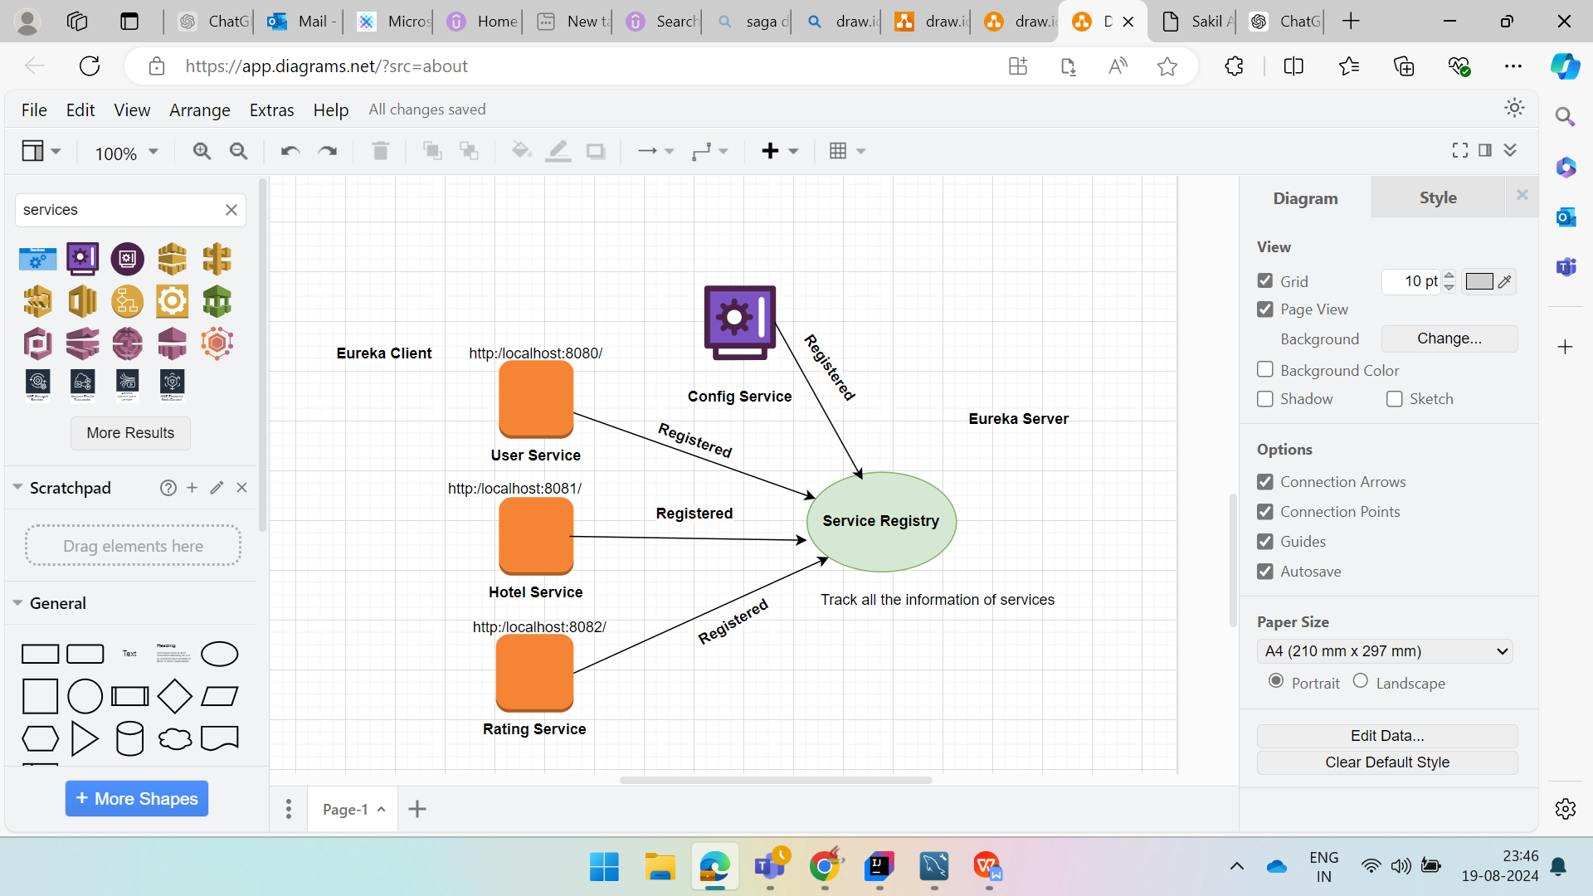

**All services and Eureka Server**